Advanced Graphics Programming (CUP688)
Tutorial 10a – Skybox

Introduction
Most 3D games will use a skybox to render behind the environment instead of a simple clear colour. This tutorial will outline what is necessary to achieve the task of rendering a skybox with correct depth and camera handling.

Prerequisites
Duplicate a working project, it must minimally have a working graphics pipeline. Your project will also need DirectX ToolKit and Resources.zip from SOL.

1. Setting Up Required COM Objects
So far, we have mostly been rendering a single object, or a single “material” at a time. To properly render a skybox, we will need to use another set of textures, shaders and their inputs, rendering context states and logic. This section will go through setting up the necessary data before we change rendering states and issue draw calls.
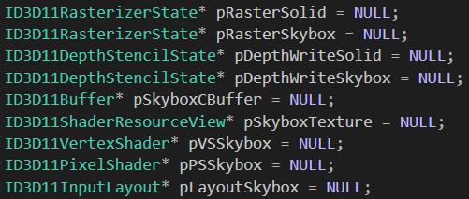
- Create the following variables. My project is still storing these as globals, but if you have a different structure and feel confident with where each member should go, you can use classes and structs to store this data.
Most of the above you should already be familiar with, but the first 4 are new.
  - pRasterSolid and pRasterSkybox – This will be used to swap between front-face and back-face culling.
  - pDepthWriteSolid and pDepthWriteSkybox – Used to disable and enable Z-buffer writing.
  - pSkyboxCBuffer – Constant buffer for the skybox shader.
  - pSkyboxTexture – Skybox cubemap texture.
  - pVSSkybox – Skybox vertex shader.
  - pPSSkybox – Skybox pixel shader.
  - pLayoutSkybox – Input layout for the skybox vertex shader.
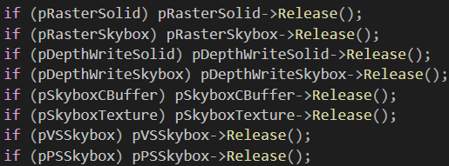
- Inside the clean up function, release all the objects you declared above.
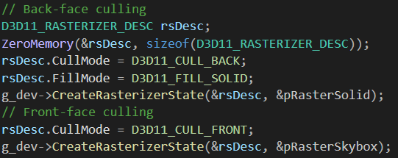
- We now need to create the rasterizer states. This will allow us to toggle between front-face and back-face culling so that we can render a cube inside-out for our skybox. We can do this inside our InitD3D function.
As the only difference between the two rasterizer states is the cull mode setting, we can use the same description object to create both but change the required setting.
Remember that you should error check creation functions like CreateRasterizerState above with the FAILED macro. You can find an example of how to do it in previous tutorials, or by scrolling through InitD3D.
You can alternatively use a separate cube mesh that is inside-out purely for rendering the skybox. This will remove the need to switch rasterizer states.
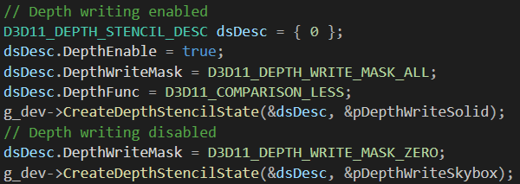
- Next, we can create the depth stencil states just after the above code.
We set depth write mask to zero to disable depth writing and follow a similar method as above of reusing the same description object. Once again, remember to error check the create functions!

2. Shader Buffers and Data
Currently, we have a single function called InitPipeline that loads a pixel and vertex shader and creates an input layout. This is fine when we only need a single set of shaders, but will quickly become out of control and repetitive if we want to use more than one set of shaders. Instead, we will create a function for loading a vertex and pixel shader that will allow us to load shaders with a single line of code.
The below code will not be using shaders compiled by the Visual Studio HLSL Compiler and will instead compile them in code. Also, no shader reflection will be used for the input layout. If you wish to use either, it shouldn’t be too difficult to convert the below code to use .cso shader files and shader reflection.
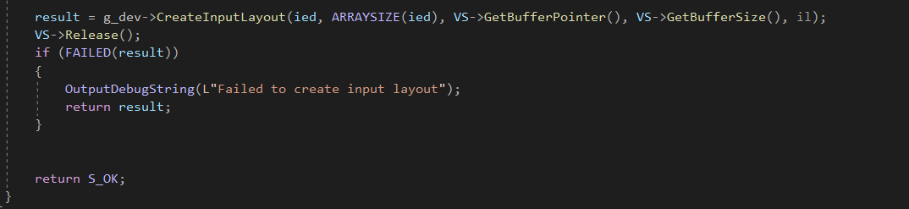
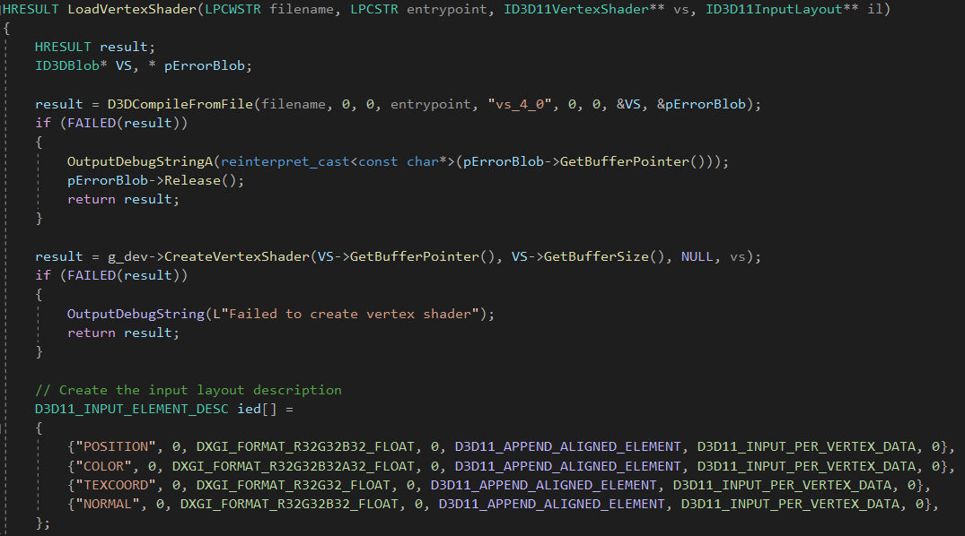
- Create a function called LoadVertexShader with the following signature. This function will load shader code, compile it, create a shader object and create an input layout.
The above code should look familiar as it’s the contents of InitPipeline, without the pixel shader part.
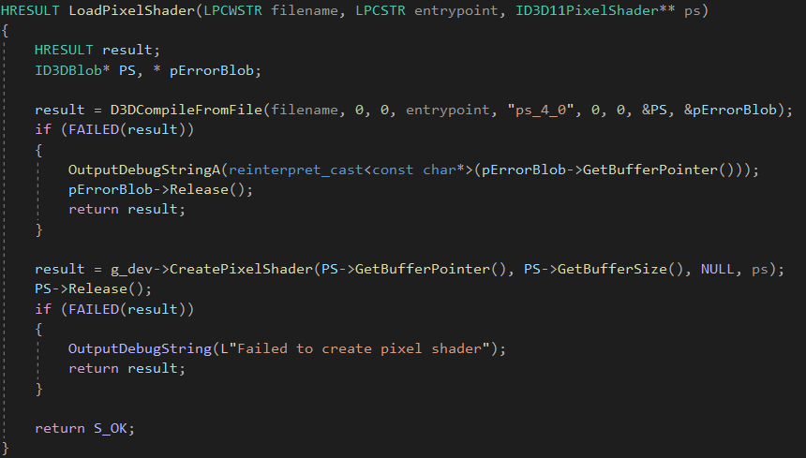
- Now create a function called LoadPixelShader. This will load and compile a pixel shader.
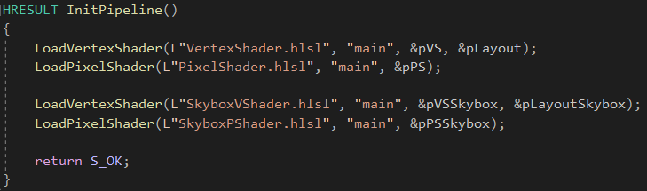
- InitPipeline can now be much cleaner looking.
The load functions return a HRESULT for error checking. It is wise to check the returns using the FAILED macro.
We will create the skybox shaders in the next section.
- Our skybox requires a cubemap texture to render with. These are stored as .dds files, Microsoft’s proprietary texture file format for DirectX. Include <DDSTextureLoader.h> and inside InitGraphics you can load one of the provided skybox cube maps from Resources.zip.
This works identically to loading files with WIC using DirectX Toolkit.
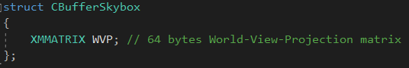
- The final data related element that needs setting up, is the constant buffer that our skybox vertex shader will use. We could reuse the same constant buffer as our normal renders, but our skybox does not need to receive any lighting information. We only need the world-view-projection matrix.
Add this struct somewhere to your code.

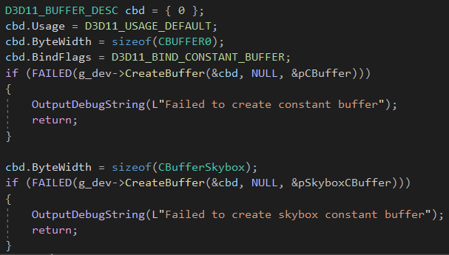
- Now create the constant buffer in InitGraphics. Once again, we can reuse the description object from our previous constant buffer.

3. Skybox Shaders
With everything set up on the C++ side, we now need to create the HLSL shaders that will be used to render the skybox.
- Create two new .hlsl files by going to Project → Add New Item → Visual C++ → HLSL. Create a vertex shader called SkyboxVShader and pixel shader called SkyboxPShader.
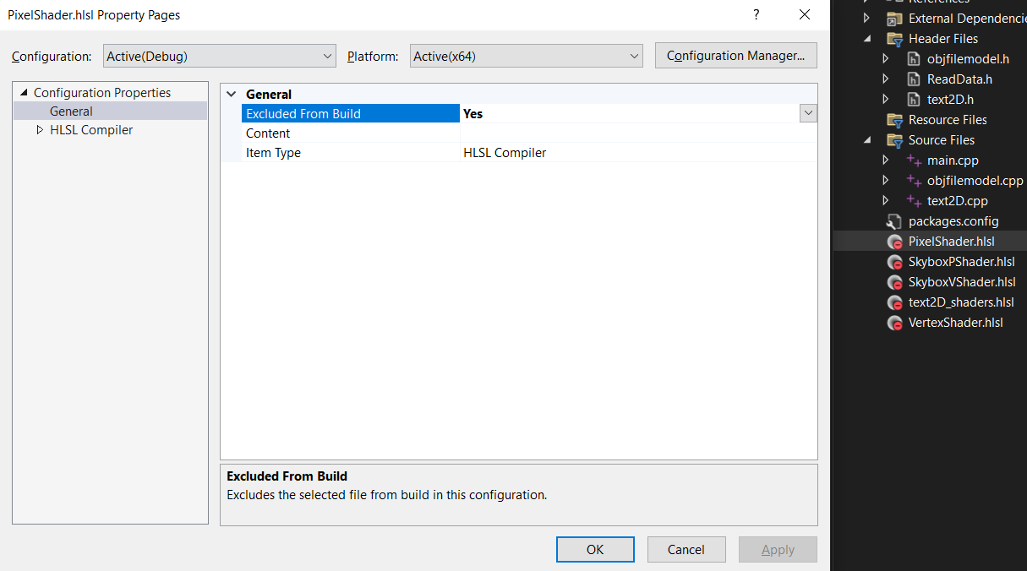
- If you are not using Visual Studio HLSL Compiler and instead using D3DCompileFromFile, exclude both shaders from the build by going to Solution Explorer → Right-click on shader → Properties → Configuration Properties → General → Excluded From Build → Yes. Do this for both shaders.

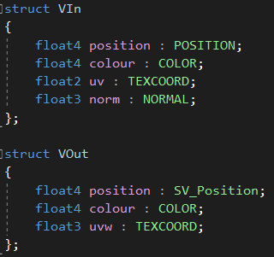
- Now open SkyboxVShader.hlsl. Create two structs for the shader inputs and outputs.
VIn is identical to what we are using in our standard shader. This also must match our input layout. VOut is very similar to our standard shader, but our texture coordinates are now a float3. This is because when sampling cubemaps, we use a direction vector instead of simple UV coordinates.
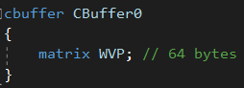
- We will also need a constant buffer to provide the position of the skybox cube to the shader, as well as the view and projection matrices. Without it, we would not be able to make the cube follow the camera making the skybox only work at world coordinates (0, 0, 0).
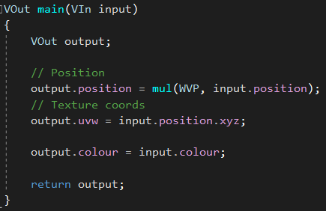
- The vertex shader for the skybox is much simple than our standard shader, as no lighting is necessary.
This is very similar to an early version of our vertex shader. All this does is move the vertex into its desired world position, use the vertex local position as the texture coordinate and “forward” the colour to the pixel shader.
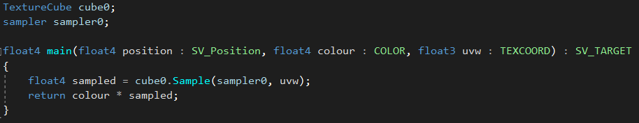
- Next, we need edit SkyboxPShader.hlsl. We just need to change the Texture2D declaration to be a CubeTexture, and use UVW instead of UV for sampling the cube map.
That’s it! Now we can issue draw calls for our skybox.

4. Skybox Draw Call START HERE SOMI
If we simply wanted to render nothing but the skybox, we could just set the correct rendering context state and render the skybox the same way that we have been rendering our objects previously. However, it’s highly unlikely to only want to render a skybox. If we try to set the state in RenderFrame it will quickly become a complicated mess. There are some steps we can take to isolate the messy code that will render the skybox.
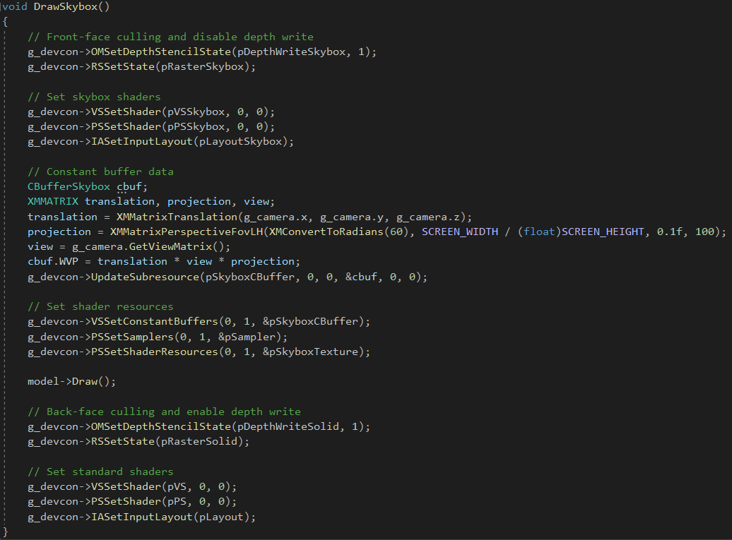
- Create a new function called DrawSkybox. It does not need to return anything or take any parameters.
The above function sets a lot of the state of the rendering context for rendering the skybox, then calculate constant buffer data and issue a draw call, before finally reverting the state back to standard rendering. Keep in mind, model is storing a standard cube mesh.
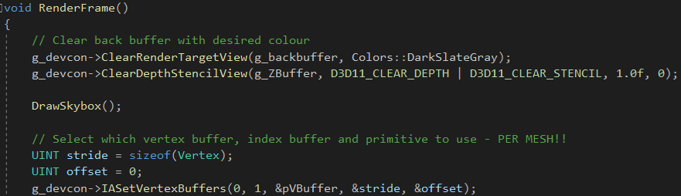
- Inside RenderFrame we can now call DrawSkybox after clearing the screen back buffer.
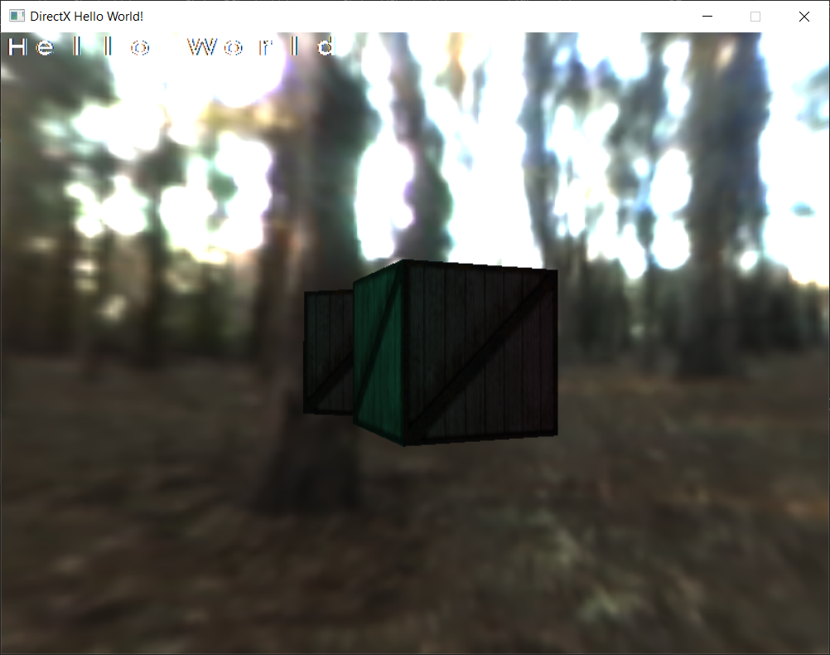
- Test the program, you should see a skybox rendered around the camera and the orientation should remain world locked.

